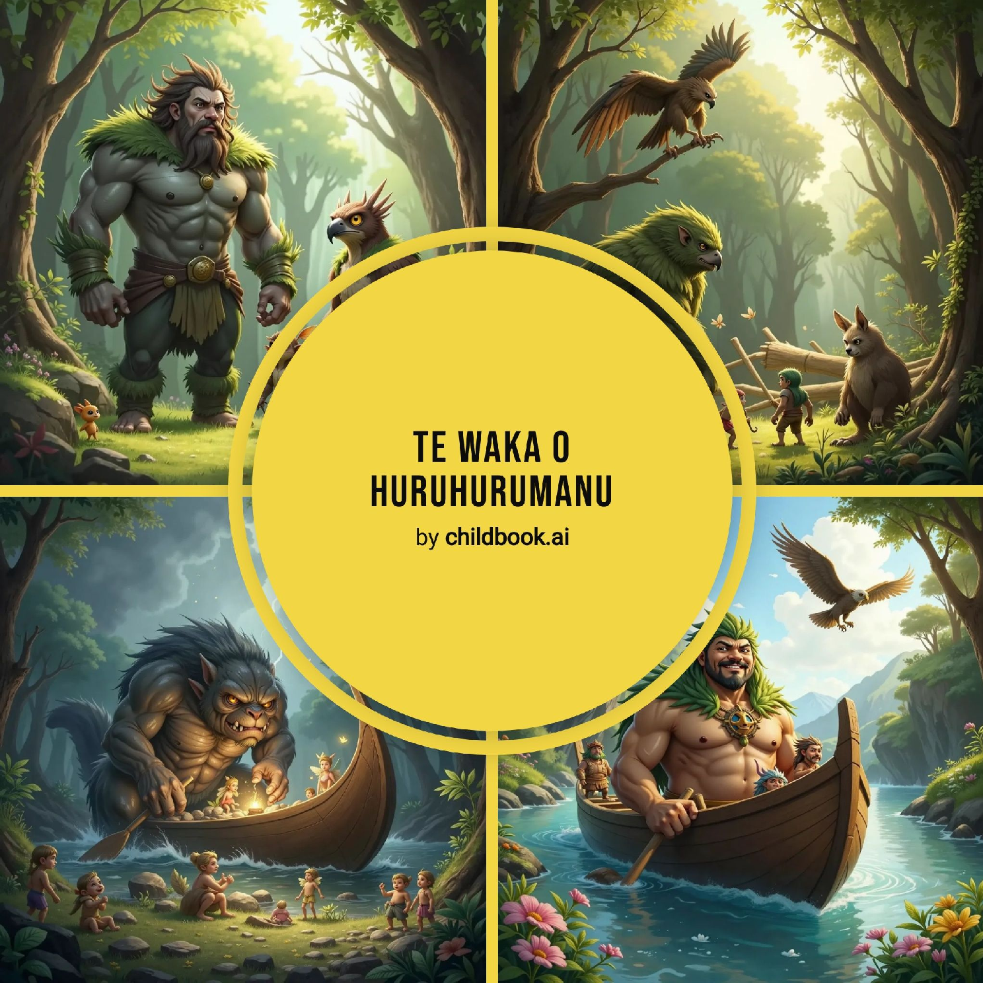

Long ago, before even the Waitaha and Rapuwai people lived in Aotearoa, giants walked the land. These weren't just any giants; they were Te Kāhui Tipua, and they arrived on a very special canoe. It was called Huruhurumanu, which meant "the canoe of feathers," and it was grand and strong.

Three giants led the way: the brothers Matau and Kōpūwai, and a giant eagle named Pouākai. Others joined them too, giants like Pukutuaro, Komako Hua, and Te Karara-Huarau. The canoe wasn't empty, either. The Māeroero, like mischievous little goblins, and the Patupaiarehe, like magical fairies, helped paddle and served the giants.

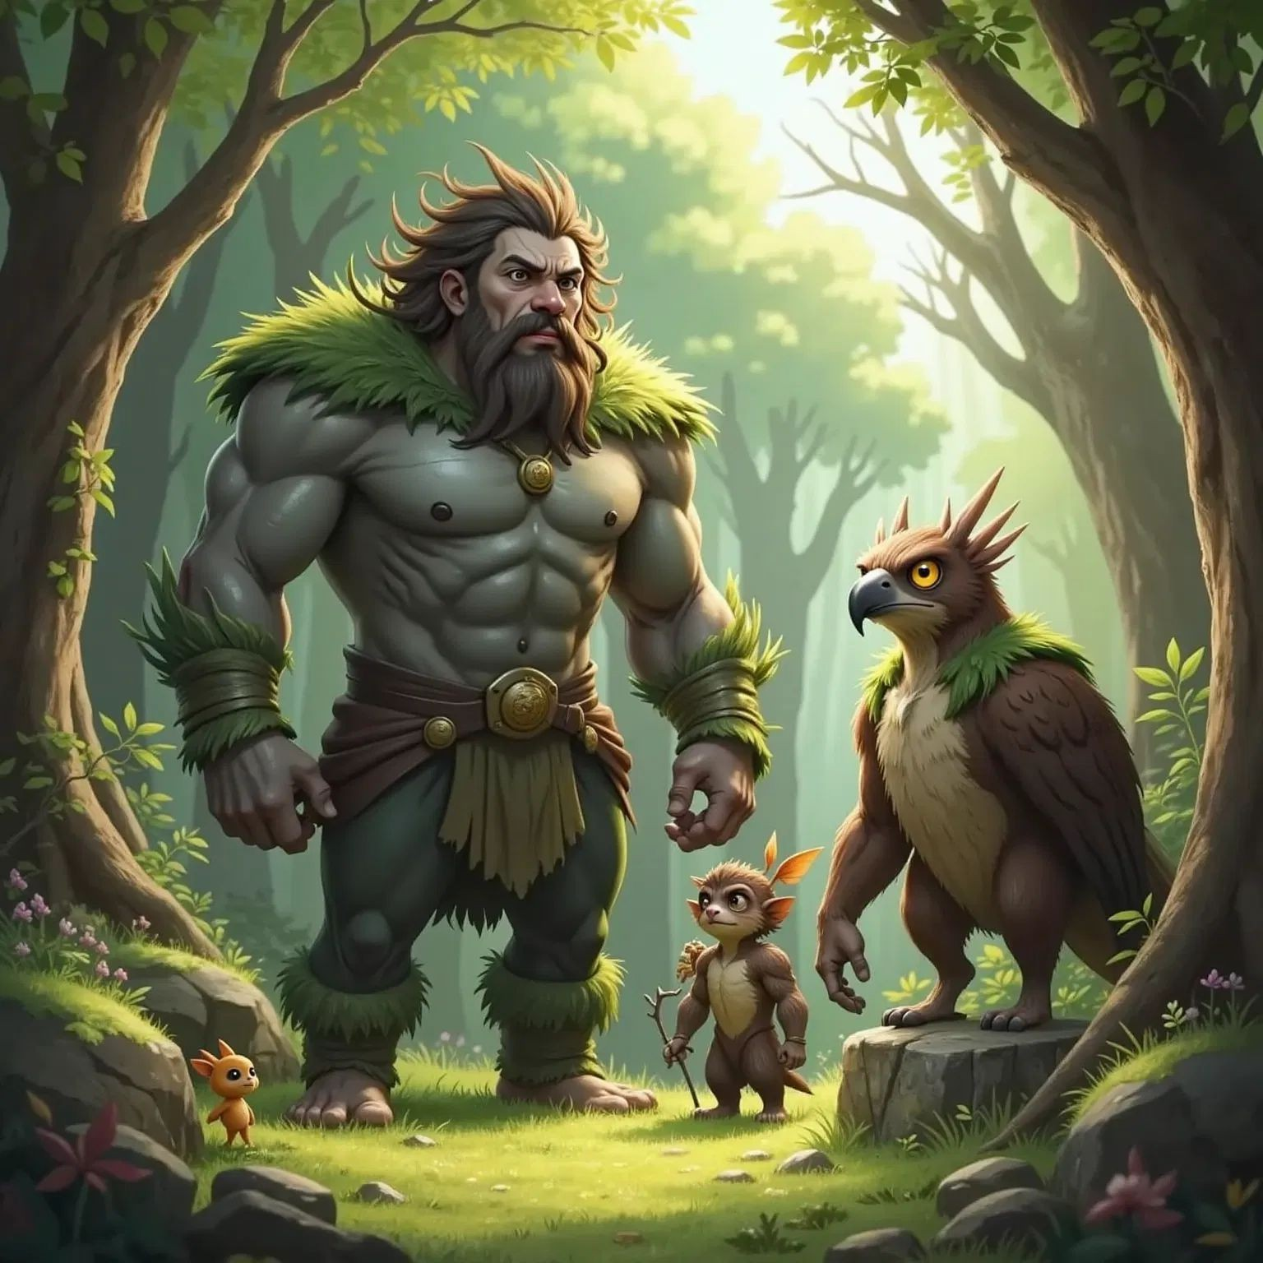

One day, the Huruhurumanu sailed into a terrible storm. Waves crashed, and the wind howled. The paddlers strained with all their might to keep the canoe afloat, but the sea was too strong. The canoe tossed and turned, throwing everything overboard. Tuna baskets, calabashes and even kumara tumbled into the sea and washed ashore at a place called Moeraki.

The storm raged on, and the Huruhurumanu couldn't withstand it. With a mighty crash, the canoe smashed against the shore, breaking into pieces. The impact created enormous waves that surged far inland. The foamy white tops of the waves turned to stone, forming the grand mountain ranges that stretch as far from the sea as the Mata-au and Kawarau rivers. One of these mountains is known as Tara-Puta, (Mount Pisa).

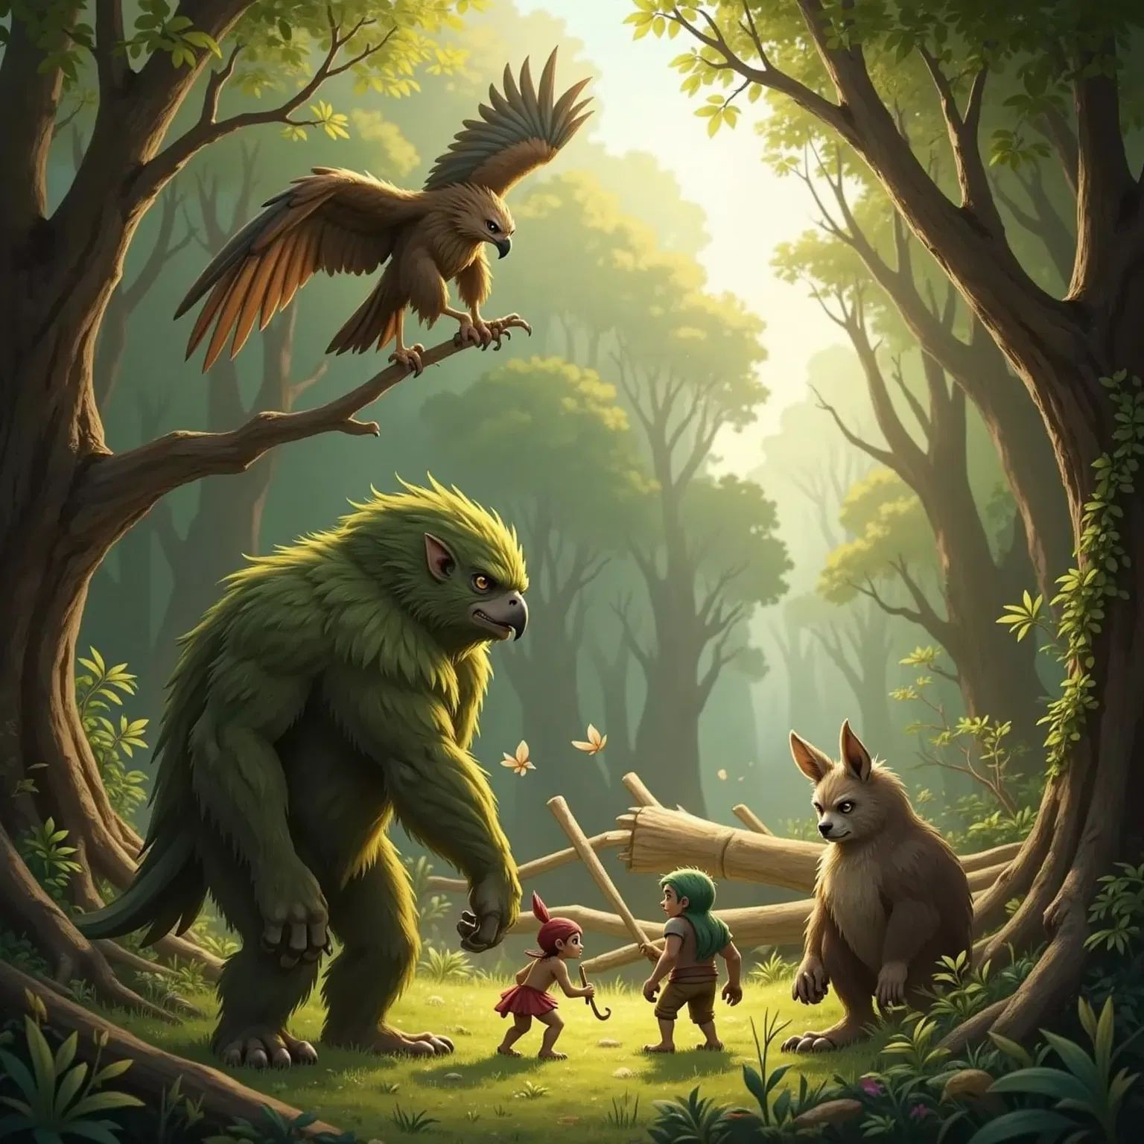

The giants, Te Kāhui Tipua, tumbled onto the shore with the wreckage of their canoe. They stood tall, shook off the water, and stepped onto the land. The paddlers and servants scrambled ashore, following their leaders. Some of the Māeroero chose to stay in the forests, becoming like wild men. Others transformed into the foothills of the Southern Alps, which the Māori call Te Tiritiri o Te Moana. The Patupaiarehe, the magical fairies, retreated to the misty mountaintops, living as spirits.

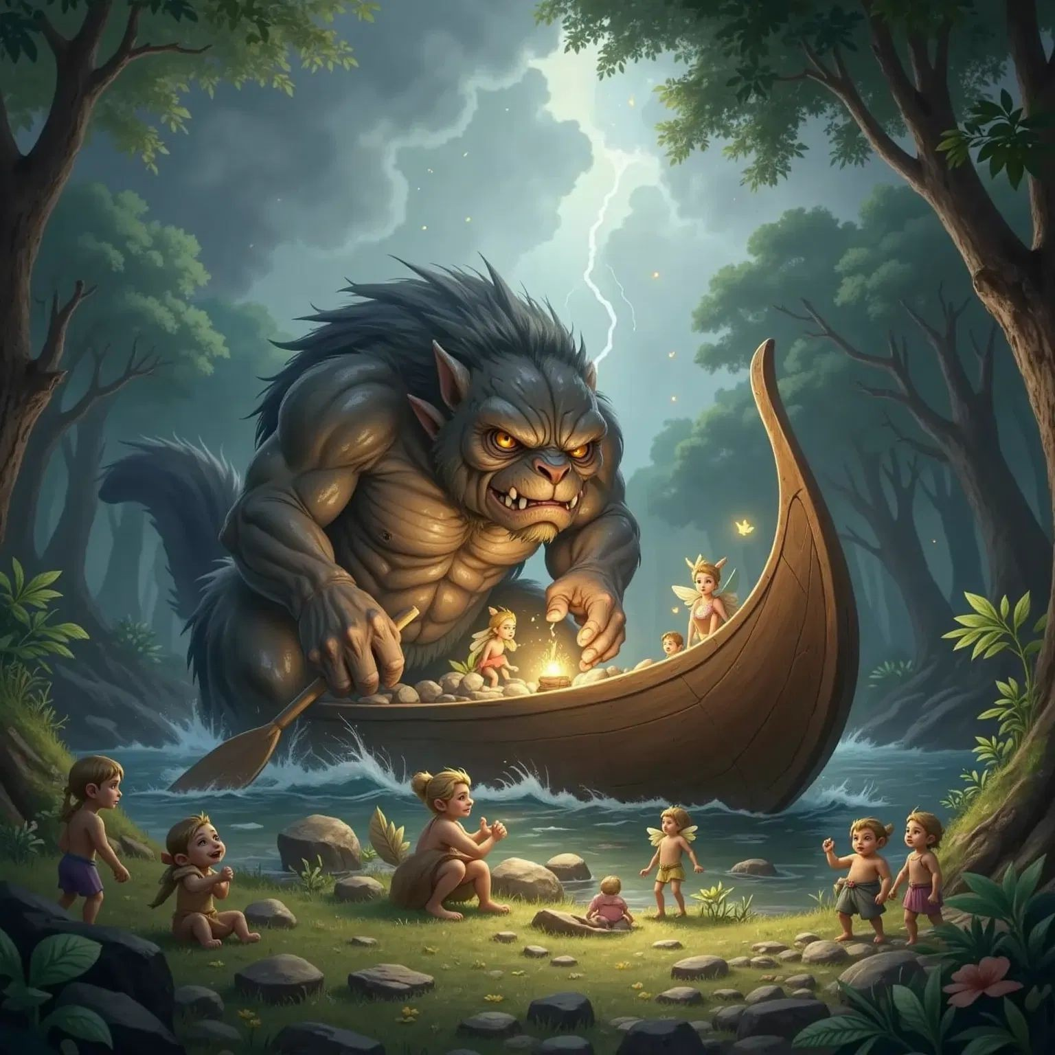

Kōpūwai found his home at Te Wairere, where the Mata-au and Kawarau rivers meet. He made his dwelling in a cave above Ōkura, now known as Cornish Point. Matau settled in Wakatipu, while Pouākai made his home at Te Pōhutu, sometimes known as Carrick range in Bannockburn. The other giants journeyed to different lakes, rivers, and coastlines all around Aotearoa.

And so, the story of the giants and their feathered canoe lives on, told and retold through the ages.

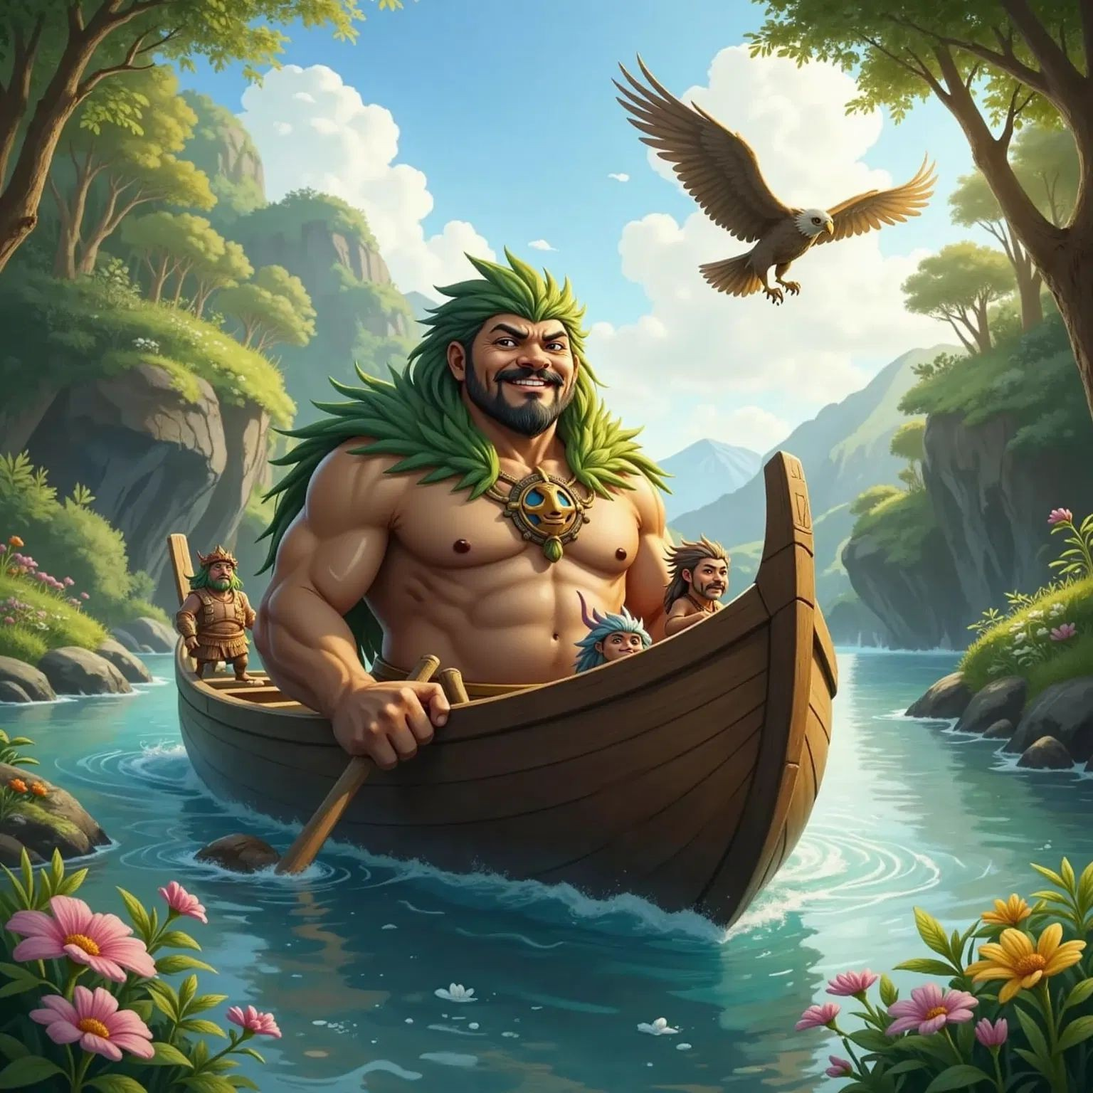

SPARK YOUR CHILD's IMAGINATION

AND CREATE PERsONALIZED CHILDREN's BOOKs WITH CHILDBOOK.AI!

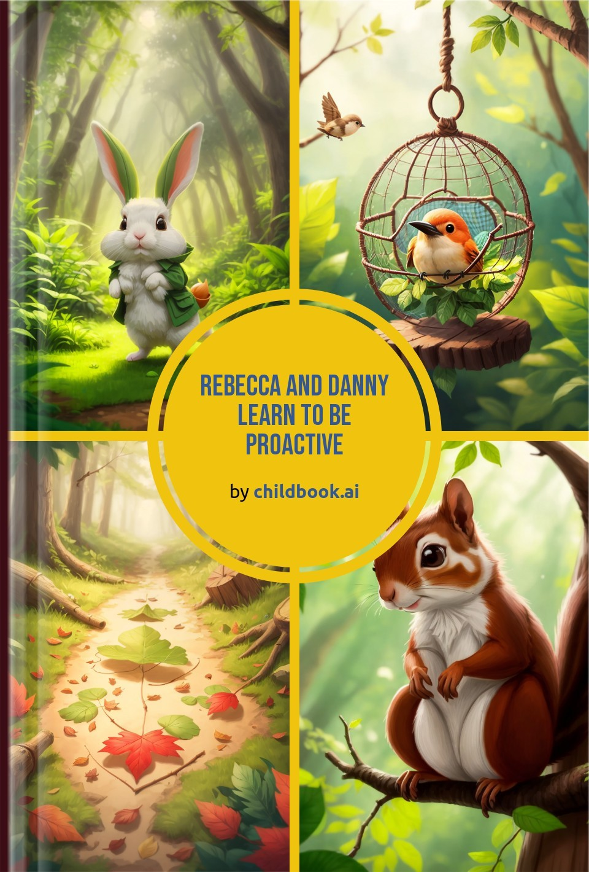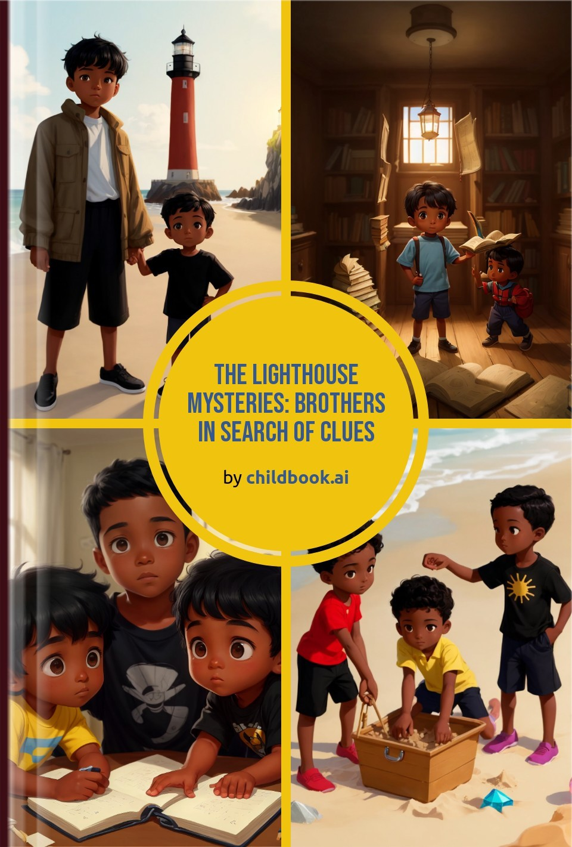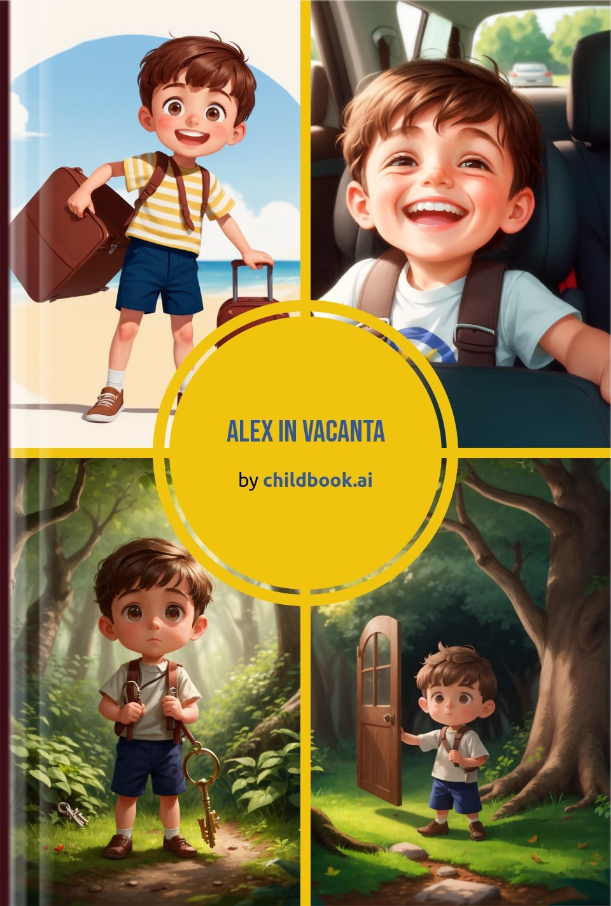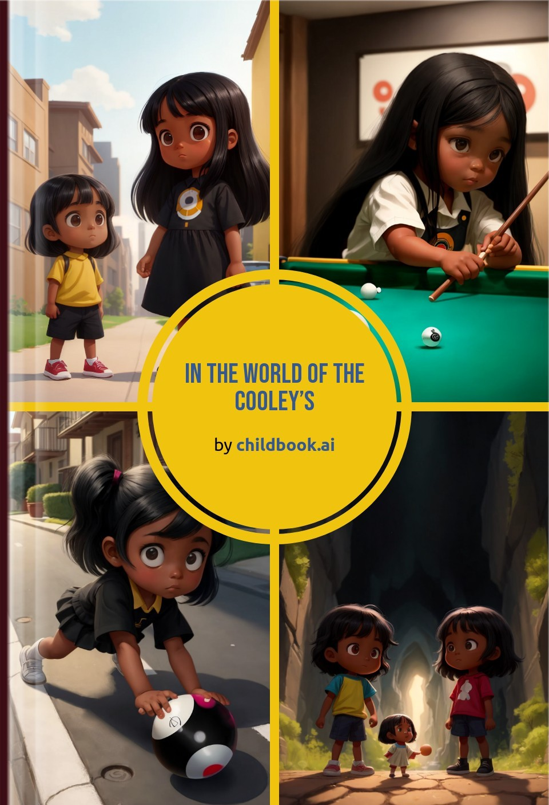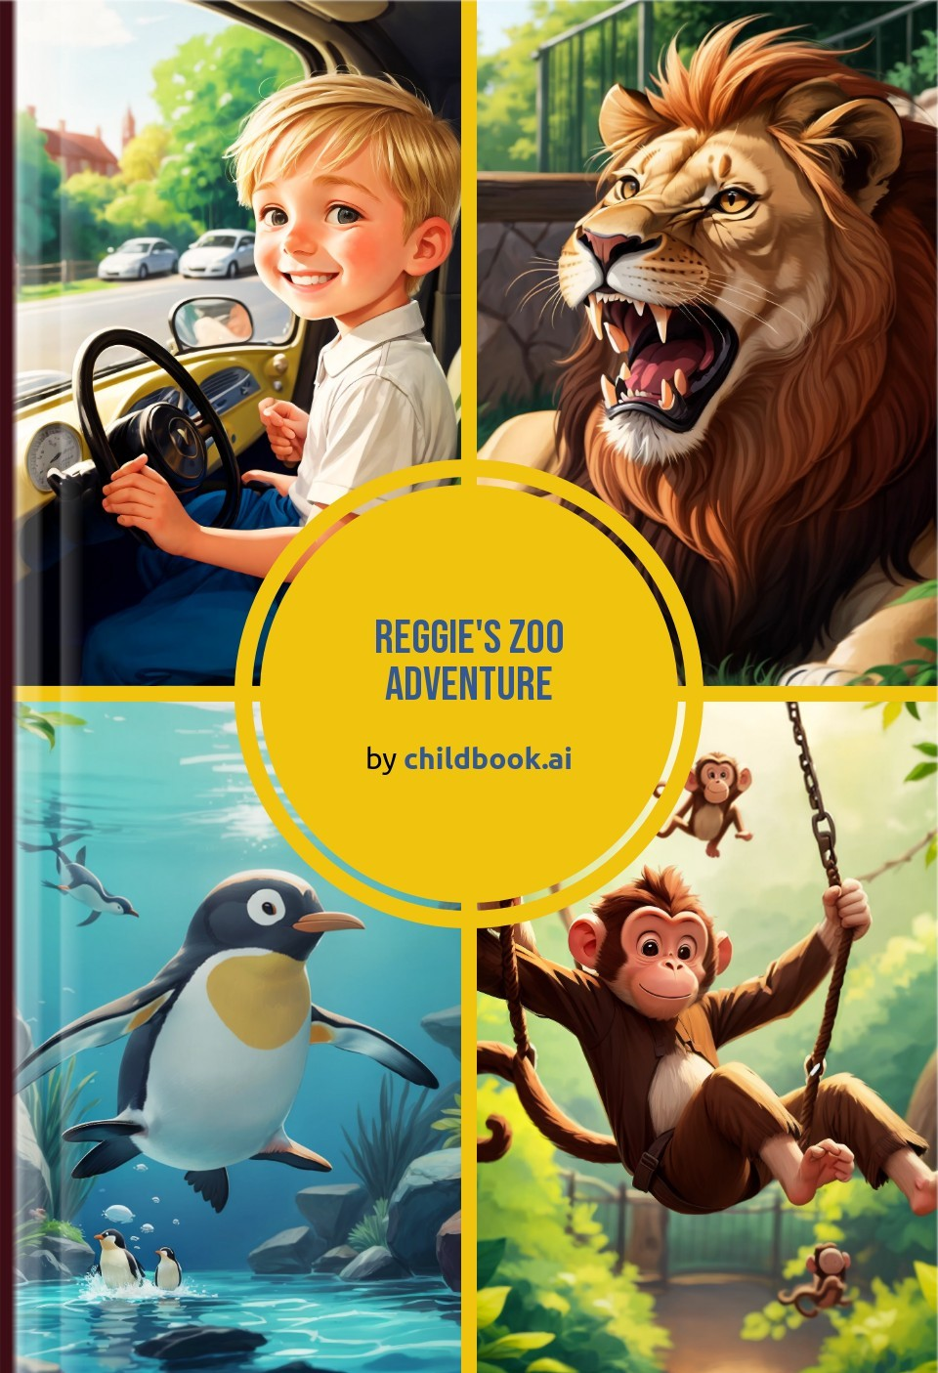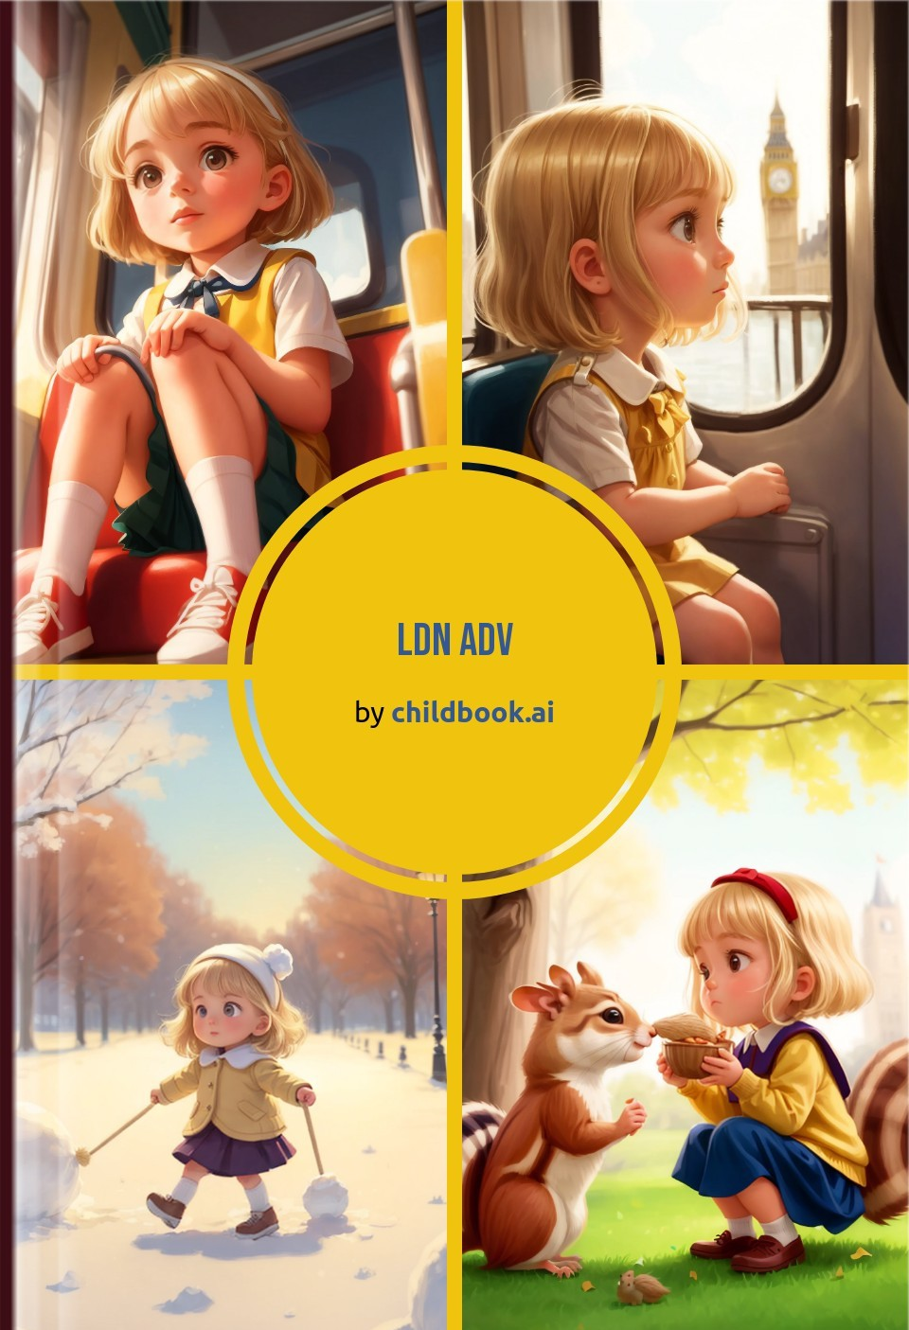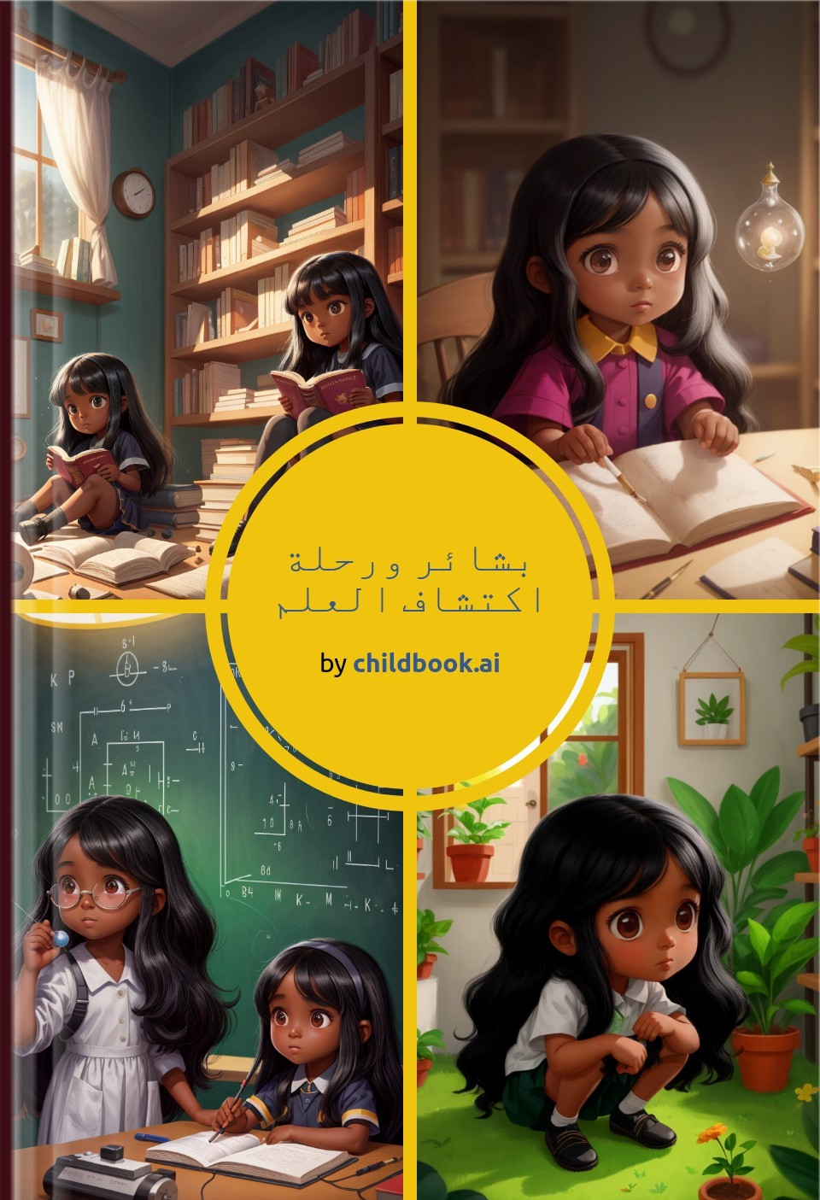

Create a unique children's story with our easy-to-use ai storybook maker. Our personalized children's books are fully customized with original characters, illustrations, and an imaginative plot.